Canopia
  - Context enrichment for the hackathon
Canopia helps hotels understand the people behind a reservation. A natural pre-arrival conversation becomes a practical brief with room preparation, service adaptations, thoughtful touches and relevant paid-service ideas, shaped by the hotel’s identity, know-how and limits.
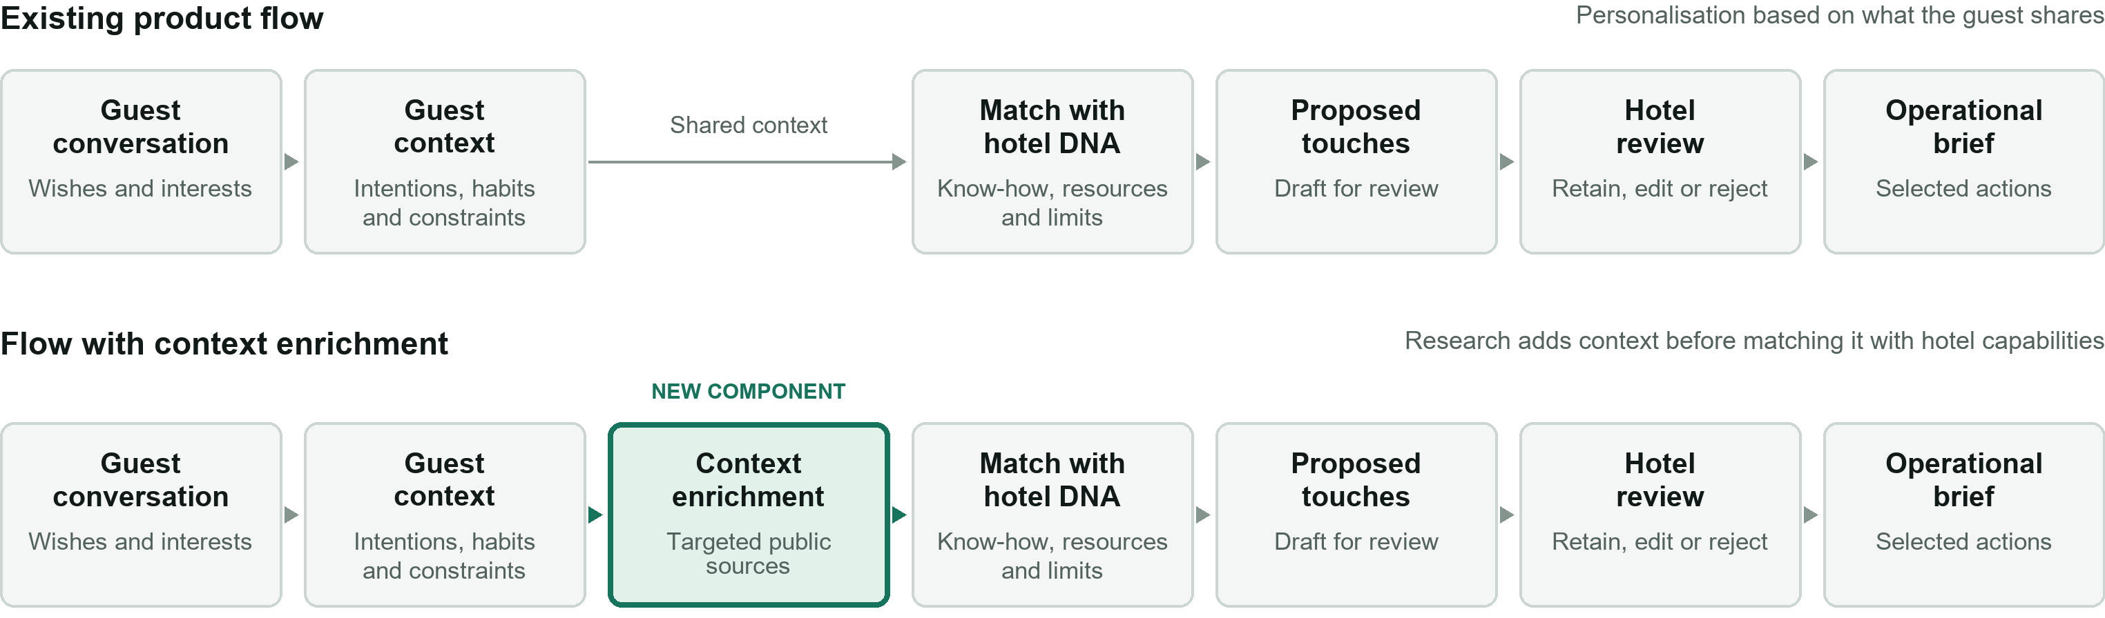
Hotel DNA also guides the conversation. Suggestions first appear in an editable draft; the hotel decides what is retained.

What the component does
Uses declared interests, stay context and test identity details to research relevant public information about the guest. Returns a few findings with sources, dates and uncertainty, then helps compose several options for hotel review.

Expected value
More specific personal touches and service ideas without lengthening the guest conversation. The added context should improve what the hotel can prepare, adapt or propose, using its documented capabilities and local knowledge.

What the hackathon should prove
Compare briefs for the same cases, with and without research. Show what the new evidence changes, which ideas the hotel would retain, and why. Relevance, traceable sources and feasibility matter more than the volume of findings.

Illustrative example “I enjoy running” → verified public runs of 8–10 km → a proposed 9 km local route for the hotel to review.
Test boundaries Declared interest · public sources · verified identity · no enrichment when uncertain · human selection before use.
Existing foundation: local app, six hotel DNA profiles, conversations and editable briefs. Research: contract only; to be built at the hackathon.
Product adoption and conditions for real-guest use remain open. Hackathon team: Once Upon a Stay.

Examples and repository guide
Appendix for the hackathon team
Private repository crosojulien-spec/canopia | GitHub main at f9a6b1b | Checked 6 October 2026

What research could change
Illustrative scenarios, not research results or confirmed hotel services. Test subjects and accessible sources must be selected before the demo.

01 Running habits
Guest cue: “I enjoy running on trips.” A correctly matched public activity page shows repeated 8–10 km runs. Instead of a generic jogging suggestion, propose a 9 km route from the hotel and a suitable departure time. The concierge confirms the route and practical arrangements.

02 A more precise musical preference
Guest cue: “I love jazz.” A public playlist attributable to the test subject suggests acoustic jazz. Propose a tailored music selection for an existing hotel arrangement, or a focused concierge search for a suitable venue. Availability, permissions and price remain to confirm.

03 Nothing reliable to add
A same-name profile cannot be linked confidently to the guest, or the findings add no useful detail. Return no enrichment and keep the conversation-based brief. Explain the rejection rather than filling the gap with an assumption.

What each result should contain
Declared cue → finding → source and date → uncertainty → proposed action → required hotel capabilities → checks still needed → human decision.

A useful demo outcome
Show baseline and enriched briefs side by side, plus accepted and discarded proposals. Keep the conversation and DNA fixed. The team should be able to explain the added value of every retained finding.

Where to find what in Git

01 Product scope and local setup
README · Product decisions
Start with the product purpose, guest discovery, human decisions and instructions for running the app.

02 The research component
Hackathon extension · shared/types.ts
Read ResearchExtensionProposal: declared interests, sourced findings, proposals, confirmations and human selection. It is a contract, not an implemented agent.

03 Conversation and brief generation
server/ai.ts · prompts/
Find the selected prompt versions and how the reservation, hotel DNA and transcript enter each AI call.

04 Hotel capabilities and limitations
data/dna/ · Review guide
Six hotel profiles, composition examples, sources and unresolved checks. Public-source profiles are not hotel-approved operating instructions.

05 Conversations and saved briefs
Sukhothai case 04 · Discovery evaluations
Read transcripts alongside their briefs and review notes. These are fictional test stays; historical outputs are fallible references.

06 Integration points in the application
server/service.ts · shared/types.ts
Inspect conversation completion, brief generation and versioning. Confirm the technical insertion point before connecting the new component.

Repository snapshot Links target the verified GitHub commit. Local English document renames and conversation-v3.1 are not yet in that commit; check synchronisation before the team starts. The research integration position is still open in the repository specification.

